**To find out if PALMS is the right Service for you please speak to the medical practice reception staff:**

**Telephone: 01382 458 333**

Please quote “Mental Health Specialist’’ or ‘‘PALMS”

Need to talk to someone prior to your appointment? You can contact these services for additional support:

**Samaritans**

Website: [www.samaritans.org](http://www.samaritans.org)

Telephone number: 116 123

Opening hours: 24/7

**Breathing Space**

Website: [www.breathingspace.scot](http://www.breathingspace.scot)

Telephone number: 0800 83 85 87

Opening hours: Monday – Thursday between 6pm to 2am

& Friday 6pm till Monday 6am

**MENTAL HEALTH CRISIS**

If you or a loved one is experiencing a mental health crisis, please contact your **GP to secure an emergency appointment**. If you require help **out of hours**, please call **NHS 24 on 111.**





**Erskine Practice**

**Arthurstone Medical Centre**

Are you worried about your mental health?

Feeling overwhelmed or low and need to talk

to someone about seeking relevant support?

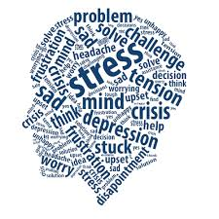 **You can self-refer to PALMS for consultation**

**PALMS is a new service run by Dundee Health and Social**

**Care Partnership within NHS Tayside.**

**This service is now available in your GP practice.**

**Who is this service for?**

* Anyone aged 16-64 years who is experiencing mental health difficulties.
* Individuals aged 16-17 years who are not enrolled in school education.
* You are not currently seeing a mental health professional (e.g. psychologist, mental health nurse, or psychiatrist)
* 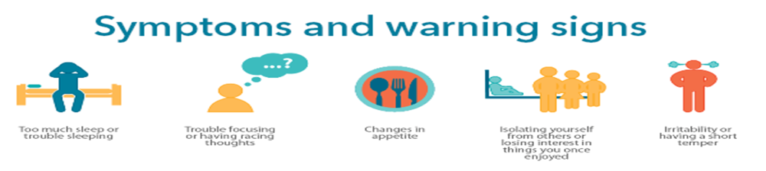You might be struggling with low mood, anxiety, self-esteem, distressing life events or other difficulties that you would like help with.

**How can I make an appointment?**

* Speak to the GP practice reception staff who can help you determine if PALMS is the right Service for you.
* The reception staff will ask you a number of questions to decide if seeing a mental health specialist is right for you.
* You do not need to see your GP to make an appointment.
* The mental health specialist will aim to see you within 5 days of contacting the reception to make an appointment.



**What happens during the appointment?**

* **During the Coronavirus outbreak, all appointments are conducted over the telephone**. The mental health specialist will contact you at the agreed time of the appointment on your telephone number.
* Appointment lasts up to 30 minutes.
* You will be encouraged to talk about your difficulties.

**What will be the outcome of the appointment?**

* The mental health specialist will assess your difficulties and then they will:
* Give advice around mental health coping strategies and self-help material.
* Signpost to local community support services.
* If appropriate, they will refer you to specialist services for further treatment.